Create 2 slaves machines in jenkins

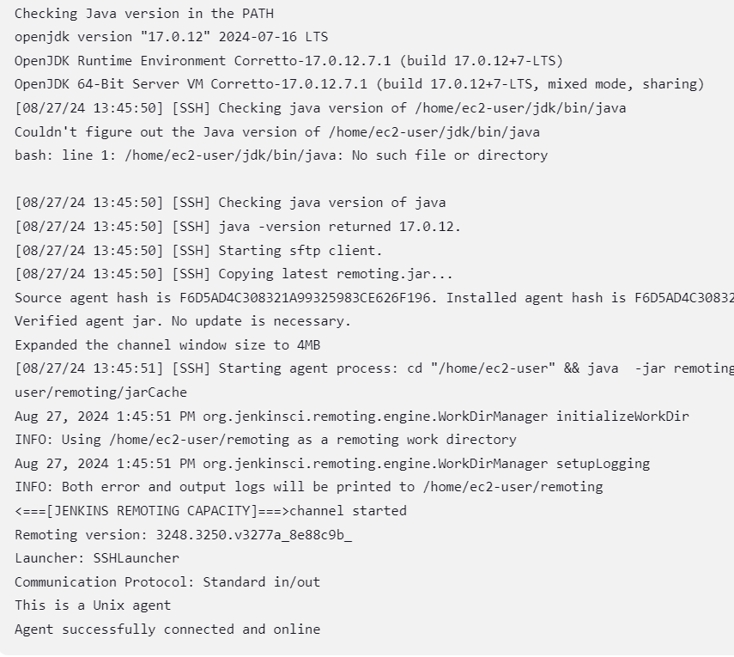

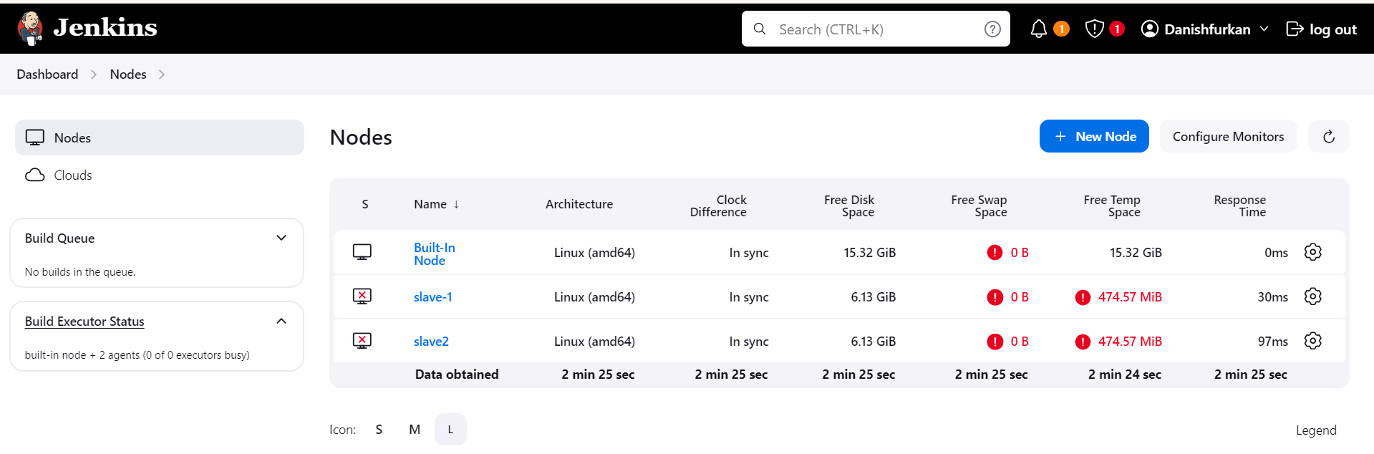

Configure webhooks to Jenkins job

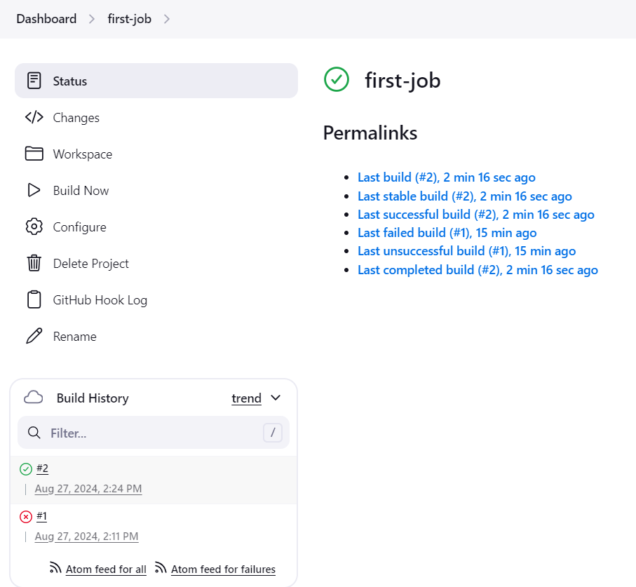

Configuire poll scm and build periodical options in Jenkins job

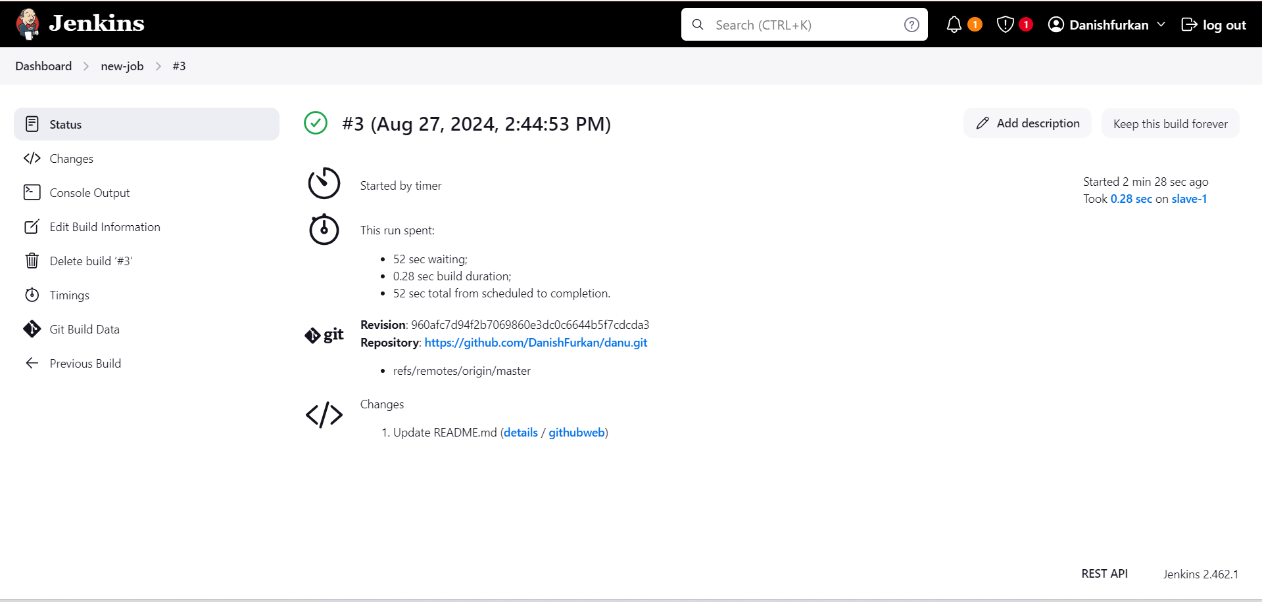

Take backup of Jenkins server by using bash script

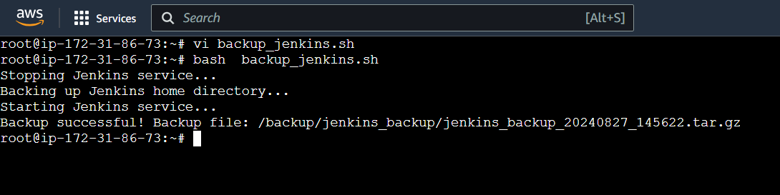

Setup a new Jenkins server and dump the backup taken in the backup of task 4

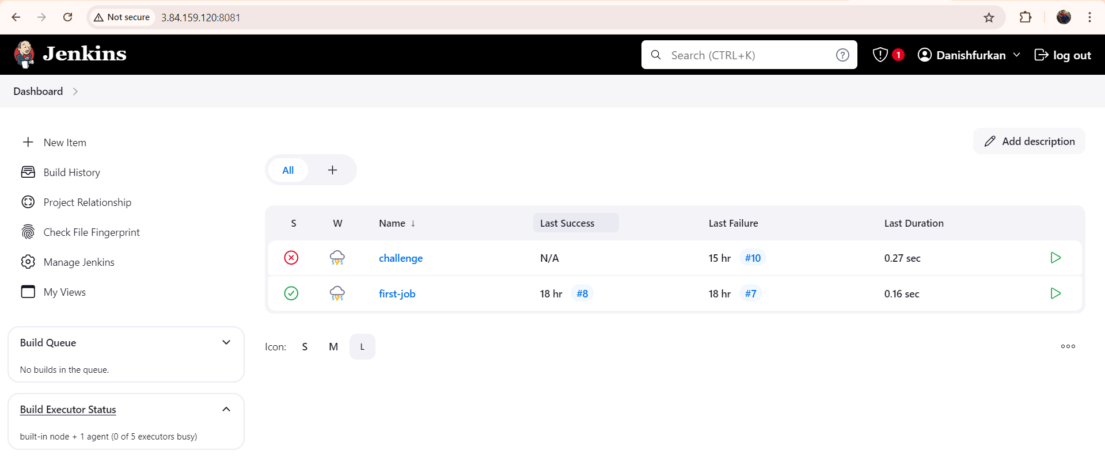

Dump server

